A PROJECT REPORT ON

MOVIE RECOMMENDATION SYSTEM USING MACHINE LEARNING

SUBMITTED IN THE FULFILLMENT OF REQUIREMENTS FOR THE MINI-PROJECT REVIEW IN ARTIFICIAL INTELLIGENCE COURSE.

SUBMITTED BY:

**N. VENKATA LAKSHMI**

APPROVAL SHEET

THIS REPORT ENTITLED “MOVIE RECOMMENDATION SYSTEM USING MACHINE LEARNING ” BY N.VENKATA LAKSHMI FROM 05- NOVEMBER 2023 TO 15-NOVEMBER 2023.

DECLARATION

I, N. VENKATA LAKSHMI here by declare that the project report entitled “MOVIE RECOMMENDATION SYSTEM” done by me is submitted in partial fulfilment of the requirements of the course.

DATE:

PLACE: SIGNATURE OF THE CANDIDATE

## ACKNOWLEDGEMENT

I am pleased to acknowledge my sincere thanks to respected faculty for their kind encouragement in doing this project and for completing it successfully. I am grateful to them.

I convey my thanks for providing me necessary support and details at the right time during the progressive reviews.

I would like to express my sincere and deep sense of gratitude to my Project Guide ,for their valuable guidance, suggestions and constant encouragement paved way for the successful completion of my project work.

# ABSTRACT

Recommendation System is a system that seeks to predict or filter preferences according to the user’s choices. Recommendation systems are utilized in a variety of areas including movies, music, news, books, research articles, search queries, social tags, and products in general, It is a simple algorithm whose aim is to provide the most relevant information to a user by discovering patterns in a dataset. The algorithm rates the items and shows the user the items that they would rate highly. An example of recommendation in action is when you visit Amazon and you notice that some items are being recommended to you or when Netflix recommends certain movies to you. They are also used by Music streaming applications such as Spotify and Deezer to recommend music that you might like.

They gradually learn your preferences over time and suggest new products which they think you’ll love.

We can make this application using python language and collaborative based filtering algorithm Collaborative filtering tackles the similarities between the users and items to perform recommendations.

We include a data set with user id, ratings, item number and time spent. With these data we use mapping technique and correlation concept to match user id and ratings. The next movie recommendation should be based on the user’s rating to watched movies.

**TABLE OF CONTENTS**

**ABSTRACT** **v**

**LIST OF FIGURES** **VIII**

**CHAPTER TITLE PAGE No.**

**No.**

**1.INTRODUCTION 1**

* 1. RELATED WORK 1
  2. EXISTING SYSTEM 2
  3. PROPOSED SYSTEM 3

1. **LITERATURE SURVEY 5**

1. **METHODOLOGY 6** 
   1. AIM OF PROJECT 6
   2. SYSTEM REQUIREMENTS 6
      1. SOFTWARE REQUIREMENTS 6
      2. HARDWARE REQUIREMENTS 6
   3. OVERVIEW OF THE PLATFORM 6
      1. PYTHON 6
      2. COLLABORATIVE FILTERING 8
      3. USER BASED FILTERING 10
      4. KNN ALGORITHM 11

**4.MODULE DESCRIPTION 13**

* 1. SYSTEM STUDY 13
     1. BENEFITS 13
     2. DIFFERENT TYPES 13
     3. CHALLENGES A RECOMMENDATION

SYSTEM FACE 14

* 1. DATA PRE-PROCESSING 14
  2. MODEL BUILDING 15
  3. DATA SET USED 15
  4. RECOMMENDATION VISUALIZATION 15

**5.RESULT CONCLUSION AND DISCUSSION**

* 1. CONCLUSION 19
  2. RESULT 19

1. **REFERENCES 20**
2. **APPENDIX 22**

## INTRODUCTION

Suggestion frameworks square measure the frameworks that square measure used to accumulate shopper fascination by understanding the client's style. These frameworks have currently become thought because of their capability to allow customised substance to shoppers that square measure of the client's advantage. Nowadays an outsized range of things square measure recorded on net business sites that create it tough to get a results of our ideal call. This is often the place wherever these frameworks assist United States by apace suggesting United States with the perfect things. Proposal frameworks facilitate shoppers notice and choose things (e.g., books, motion photos, eateries) from the big variety accessible on the online or in different electronic knowledge sources. Given a massive arrangement of things and a portrayal of the client's needs, they gift to the consumer a bit arrangement of the items that square measure applicable to the depiction. Also, a movie proposal framework provides a degree of solace and personalization that assists the consumer with collaborating the framework and watch motion photos that take into consideration his needs. Giving this degree of solace to the consumer was our essential inspiration in choosing film proposal framework as our BE Project. The most reason for our framework is to impose motion photos to its shoppers obsessed with their review history and evaluations that they provide. The framework can likewise impose totally different E-trade organizations to advertise their things to specific shoppers obsessed with the category of films they like. Made-to-order proposal motors facilitate a large variety of people slender the universe of doubtless movies to accommodate their exceptional tastes. Community separating and content based mostly winnow square measure the square measure prime ways in which to traumatize provide suggestion to shoppers. The 2 of them square measure best relevant in specific things in light-weight of their explicit smart and dangerous times. During this paper we've projected a emulsified methodology with the tip goal that each the calculations supplement one another consequently rising presentation and exactness of the of our framework

### 1.1 RELATED WORK

Film proposals utilizing a number of procedures are widely targeted within the previous a few years. Models incorporate a proposal framework utilizing the ALS calculation, a suggestion smitten by the coefficient procedure, thing likeness based mostly synergistic separation. These procedures would like earlier information regarding the appraisals for the motion photos that square measure made by the shopper. These strategies significantly use film attentiveness datasets for assessment functions. Nonetheless, these frameworks aren't somewhat actual, and analysis is continuous to boost the continuing exhibition of those frameworks. Style and Implementation of cooperative Filtering Approach utilizing KNN Cui, Bei-Bei[2] has self-addressed the suggestion framework Utilizing the rating and likeness among the 2 clients; the framework prescribes an issue to the shopper for the dynamic. At that time separate the film informational index into Associate in nursing unrated and evaluated take a look at set with the help of the KNN model. It will counsel the motion photos to the obscure shoppers through shopper tour of duty information, furthermore, it will create new and not thought film suggestions as indicated by the film's set of experiences and score. The info set during this approach is that the MYSQL data base. The tour of duty framework for a shopper can snap the client's outer and interior conduct qualities, and these attributes square measure place away within the shopper information base through a login module for the shopper. The to a lower place figure.1.Portrays their compelling technique of approach for a collective sifting approach utilizing KNN. Comparison with completely different calculations. In [4], Goutham Miryala projected an identical investigation of ALS on completely different calculations. still, it's seen that utilizing a additional broad making ready dataset of 80-20 (Training - Testing) yields a model that includes a lower RMSE once contrasted with the 60-40 (Preparing - Testing) dataset. The result shows that the upper regularization boundary expands RMSE and therefore the different method around. The ALS calculation is contrasted and SVD, KNN, and Normal Indicator, and therefore the outcomes show that ALS is that the best calculation for the suggestion framework.

**1.1 EXISTING SYSTEM**

The most well-known sorts of suggestion frameworks square measure content-based and shared separation recommendation frameworks. In shared separation, the conduct of a gatheringof shoppers is employed to form proposals to completely different shoppers. The suggestion depends on the inclination of various shoppers. An easy model would bring down a movie to a shopper smitten by the method that their companion treasured the film. There square measure 2 styles of communitarian models Memory-based ways and Model-based techniques. The top of memory-based strategies is that {they square straightforward to actualize and therefore the succeeding suggestions are frequently straightforward to clarify. they're divided into two: User-based synergistic sifting: during this model, things square measure prescribed to a shopper smitten by the method that the things are most wellliked by shoppers just like the shopper. For example : if Derrick and Dennis like similar films and another film begin that Derick like, at that time we will bring down that film to Dennis in lightweight of the very fact that Derrick and Dennis seem to love similar motion photos. Item-based cooperative separating: These frameworks acknowledge comparative things smitten by clients' past evaluations. for example, if shoppers A, B, and C gave a 5-star rating to books X and Y then once a shopper D purchases book Y they likewise get a suggestion to shop for book X on the grounds that the framework distinguishes book X and Y as comparative smitten by the evaluations of shoppers A, B, and C. Model-put a long ways square measure based mostly with relevance Matrix resolving and square measure higher at managing scantiness. They’re created utilizing data mining, AI calculations to anticipate clients' evaluating of unrated things. During this methodology procedures, for instance, spatiality decrease square measure used to boost truth. Instances of such model-based ways incorporate call trees, Rule-based Model, theorem Model, and inert issue models. Content-based frameworks use data like category, maker, someone, entertainer to counsel things say motion photos or music. Such a proposal would be for instance suggesting eternity War that enclosed Vin Diesel since someone watched and enjoyed The Fate of the Furious. Also, you'll get music proposals from specific specialists since you really liked their music. Content-put along frameworks square measure based mostly with relevance the chance that within the event that you simply most well-liked a particular issue you're well on the thanks to like one thing that's love it.

**DISADVANTAGES**

* It does not work for one more shopper UN agency has not appraised any issue nevertheless as enough appraisals square measure needed substance based mostly recommendation assesses the shopper inclinations and provides actual proposals. Complex interface No suggestion of lucky things.
* Limited Content Analysis-The recommendation does not work if the framework neglects to acknowledge the items cap a shopper likes from the items that he does not look after.

**1.2 PROPOSED SYSTEM**

Collaborative filtering (CF) is one of the most widely adopted and successful recommendation approaches. Unlike many content-based approaches which utilize the attributes of users and items, CF approaches make predictions by using only the user-item interaction information. These methods can capture the hidden connections between users and items and have the ability to provide serendipitous items which are helpful to improve the diversity of recommendation. recommendation systems have been indispensable nowadays due to the incredible increasing of information in the world, especially on the Web. These systems apply knowledge discovery techniques to make personalized recommendations that can help people sift through huge amount of available articles, movies, music, web pages, etc. Popular examples of such systems include product recommendation in Amazon, music recommendation in Last.fm, and movie recommendation in Movie lens.

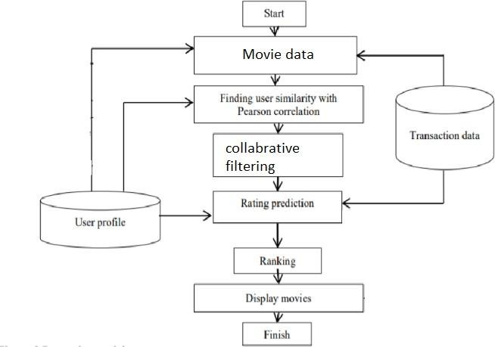

**FIG 1 SYSTEM ARCHITECTURE**

**ADVANTAGES OF THE PROPOSED SYSTEM**

* It is subject to the association between shoppers that suggests that it's contentautonomous. Scalable client administrations.
* CF recommendation frameworks will propose lucky things by noticing comparative leaning individuals' conduct.

* They will create real quality analysis of things by considering completely different folks teams insight.

**CHAPTER 2**

### LITERATURE SURVEY

Movie recommendation system is based on collaborative filtering approach. Collaborative filtering makes use of information provided by user. That information is analyzed and a movie is recommended to the users which are arranged with the movie with highest rating first. Luis M Capos et al has analyzed two traditional recommendation systems i.e. content based filtering and collaborative filtering. As both of them have their own drawbacks he proposed a new system which is a combination of Bayesian network and collaborative filtering. A hybrid system has been presented by Harpreet Kaur et al. The system uses a mix of content as well as collaborative filtering algorithm. The context of the movies is also considered while recommending. The user - user relationship as well as user - item relationship plays a role in the recommendation. The user specific information or item specific information is clubbed to form a cluster by Utkarsh Gupta et al. using chameleon. This is an efficient technique based on Hierarchical clustering for recommendation system. To predict the rating of an item voting system is used. The proposed system has lower error and has better clustering of similar items. Urszula Kużelewska et al. proposed clustering as a way to deal with recommendation systems. Two methods of computing cluster representatives were presented and evaluated. Centroid-based solution and memory-based collaborative filtering methods were used as a basis for comparing effectiveness of the proposed two methods. The result was a significant increase in the accuracy of the generated recommendations when compared to just centroid-based method. Costin-Gabriel Chiru et al. proposed Movie Recommendation, a system which uses the information known about the user to provide movie recommendations. This system attempts to solve the problem of unique recommendations which results from ignoring the data specific to the user. The psychological profile of the user, their watching history and the data involving movie scores from other websites is collected. They are based on aggregate similarity calculation. The system is a hybrid model which uses both content based filtering and collaborative filtering. To predict the difficulty level of each case for each trainee Hongli LIn et al. proposed a method called contentboosted collaborative filtering (CBCF).The algorithm is divided into two stages, First being the content-based filtering that improves the existing trainee case ratings data and the second being collaborative filtering that provides the final predictions. The CBCF algorithm involves the advantages of both CBF and CF, while at the same time, overcoming both their disadvantages.

**CHAPTER 3**

**METHODOLOGY**

### 3.1 AIM OF THE PROJECT

To implement a recommendation for movies, based on the content of providing the most relevant information to a user by discovering patterns in a dataset. The algorithm rates the items and shows the user the items that they would rate highly.

### 3.2 SYSTEM REQUIREMENTS

#### 3.2.1 SOFTWARE REQUIREMENTS

Ø Operating system : Windows 7 and above (64-bit).

|  |  |
| --- | --- |
| Ø Python    **3.2.2 HARDWARE REQUIREMENTS** | : 3.6 |
| Ø Hard disk | : 80GB or more |
| Ø Ram | : 70Mb or more |
| Ø Processor | : : Intel Core Duo 2.0 GHz or more |

### 3.3 OVERVIEW OF THE PLATFORM

#### 3.3.1 Python

Python is a widely used general-purpose, high level programming language. It was initially designed by Guido van Rossum in 1991 and developed by Python Software Foundation. It was mainly developed for emphasis on code readability, and its syntax allows programmers to express concepts in fewer lines of code. Python is a programming language that lets you work quickly and integrate systems more efficiently.

**What can Python do?**

Python can be used on a server to create web applications.

* Python can be used alongside software to create workflows.

Python can connect to database systems. It can also read and modify files.

* Python can be used to handle big data and perform complex mathematics.
* Python can be used for rapid prototyping, or for production-ready software development.

**Why Python?**

Python works on different platforms (Windows, Mac, Linux, Raspberry Pi, etc).

Python has a simple syntax similar to the English language.

* Python has syntax that allows developers to write programs with fewer lines than some other programming languages.
* Python runs on an interpreter system, meaning that code can be executed as soon as it is written.

This means that prototyping can be very quick.

* Python can be treated in a procedural way, an object-orientated way or a functional way

#### Good to know

* The most recent major version of Python is Python 3, which we shall be using in this tutorial. However, Python 2, although not being updated with anything other than security updates, is still quite popular.
* Python 2.0 was released in 2000, and the 2.x versions were the prevalent releases until December 2008. At that time, the development team made the decision to release version 3.0, which contained a few relatively small but significant changes that were not backward compatible with the 2.x versions. Python 2 and 3 are very similar, and some features of Python 3 have been backported to Python 2. But in general, they remain not quite compatible.
* Both Python 2 and 3 have continued to be maintained and developed, with periodic release updates for both. As of this writing, the most recent versions available are 2.7.15 and 3.6.5. However, an official End of Life date of 9 January 1, 2020 has been established for Python 2, after which time it will no longer be maintained.
* Python is still maintained by a core development team at the Institute, and Guido is still in charge, having been given the title of BDFL (Benevolent Dictator For Life) by the Python community. The name Python, by the way, derives not from the snake, but from the British comedy troupe Monty

Python’s Flying Circus, of which Guido was, and presumably still is, a fan. It is common to find references to Monty Python sketches and movies scattered throughout the Python documentation.

* It is possible to write Python in an Integrated Development Environment,such as Thonny, Pycharm, Netbeans or Eclipse which are particularly useful when managing larger collections of Python files.

#### Python Syntax compared to other programming languages

* Python was designed to for readability, and has some similarities to the English language with influence from mathematics. Python uses new lines to complete a command, as opposed to other programming languages which often use semicolons or parentheses. Python relies on indentation, using whitespace, to define scope; such as the scope of loops, functions and classes. Other programming languages often use curly-brackets for this purpose. Python is Interpreted Many languages are compiled, meaning the source code you create needs to be translated into machine code, the language of your computer’s processor, before it can be run. Programs written in an interpreted language are passed straight to an interpreter that runs them directly.
* This makes for a quicker development cycle because you just type in your code and run it, without the intermediate compilation step.
* One potential downside to interpreted languages is execution speed. Programs that are compiled into the native language of the computer processor tend to run more quickly than interpreted programs. For some 10 applications that are particularly computationally intensive, like graphics processing or intense number crunching, this can be limiting.
* In practice, however, for most programs, the difference in execution speed is measured in milliseconds, or seconds at most, and not appreciably noticeable to a human user. The expediency of coding in an interpreted language is typically worth it for most applications.
* For all its syntactical simplicity, Python supports most constructs that would be expected in a very high-level language, including complex dynamic data types, structured and functional programming, and object-oriented programming.
* Additionally, a very extensive library of classes and functions is available that provides capability well beyond what is built into the language, such as database manipulation or GUI programming.
* Python accomplishes what many programming languages don’t: the language itself is simply designed, but it is very versatile in terms of what you can accomplish with it. **3.3.2 Collaborative Filtering**

Collaborative filtering is a technique used by recommendation system. Collaborative filtering has two senses, a narrow one and a more general one.

In the newer, narrower sense, collaborative filtering is a method of making automatic predictions (filtering) about the interests of a user by collecting preferences or taste information from many users (collaborating). The underlying assumption of the collaborative filtering approach is that if a person *A* has the same opinion as a person *B* on an issue, A is more likely to have B's opinion on a different issue than that of a randomly chosen person. For example, a collaborative filtering recommendation system for television tastes could make predictions about which television show a user should like given a partial list of that user's tastes (likes or dislikes). Note that these predictions are specific to the user, but use information gleaned from many users. This differs from the simpler approach of giving an average (non-specific) score for each item of interest, for example based on its number of votes.

In the more general sense, collaborative filtering is the process of filtering for information or patterns using techniques involving collaboration among multiple agents, viewpoints, data sources, etc. Applications of collaborative filtering typically involve very large data sets. Collaborative filtering methods have been applied to many different kinds of data including: sensing and monitoring data, such as in mineral exploration, environmental sensing over large areas or multiple sensors; financial data, such as financial service institutions that integrate many financial sources; or in electronic commerce and web applications where the focus is on user data, etc. The remainder of this discussion focuses on collaborative filtering for user data, although some of the methods and approaches may apply to the other major applications as well.

The growth of the internet has made it much more difficult to effectively extract useful information from all the available online information. The overwhelming amount of data necessitates mechanisms for efficient information filtering Collaborative filtering is one of the techniques used for dealing with this problem.

The motivation for collaborative filtering comes from the idea that people often get the best recommendations from someone with tastes similar to themselves. Collaborative filtering encompasses techniques for matching people with similar interests and making recommendations on this basis.

Collaborative filtering algorithms often require (1) users' active participation, (2) an easy way to represent users' interests, and (3) algorithms that are able to match people with similar interests.

Typically, the workflow of a collaborative filtering system is:

1. A user expresses his or her preferences by rating items (e.g. books, movies or CDs) of the system. These ratings can be viewed as an approximate representation of the user's interest in the corresponding domain.
2. The system matches this user's ratings against other users' and finds the people with most "similar" tastes.
3. With similar users, the system recommends items that the similar users have rated highly but not yet being rated by this user (presumably the absence of rating is often considered as the unfamiliarity of an item)

A key problem of collaborative filtering is how to combine and weight the preferences of user neighbors. Sometimes, users can immediately rate the recommended items. As a result, the system gains an increasingly accurate representation of user preferences over time.

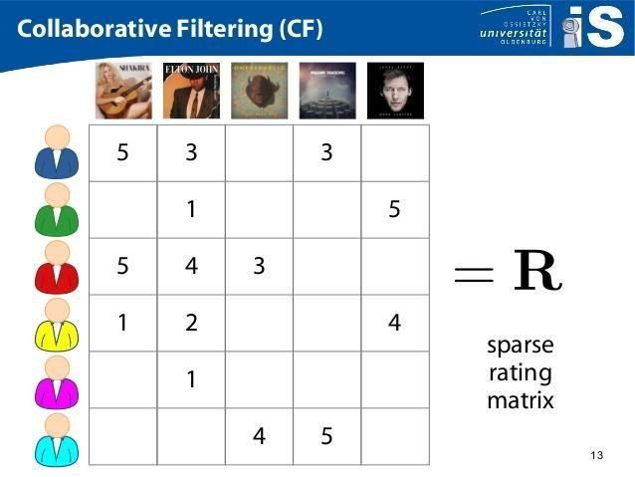

FIG 2 COLLABORATIVE FILTERING (CF)

#### 3.3.3 USER BASED FILTERING

Imagine that we want to recommend a movie to our friend *Stanley*. We could assume that similar people will have similar taste. Suppose that me and *Stanley* have seen the same movies, and we rated them all almost identically. But Stanley hasn’t seen *‘The Godfather: Part II’* and I did*.* If I love that movie, it sounds logical to think that he will too. With that, we have created an artificial rating based on our similarity.

Well, UB-CF uses that logic and recommends items by finding similar users to the *active user* (to whom we are trying to recommend a movie). A specific application of this is the user-based nearest neighbor algorithm. This algorithm needs two tasks:

In other words, we are creating a User-Item Matrix, predicting the ratings on items the active user has not see, based on the other similar users. This technique is memory based.

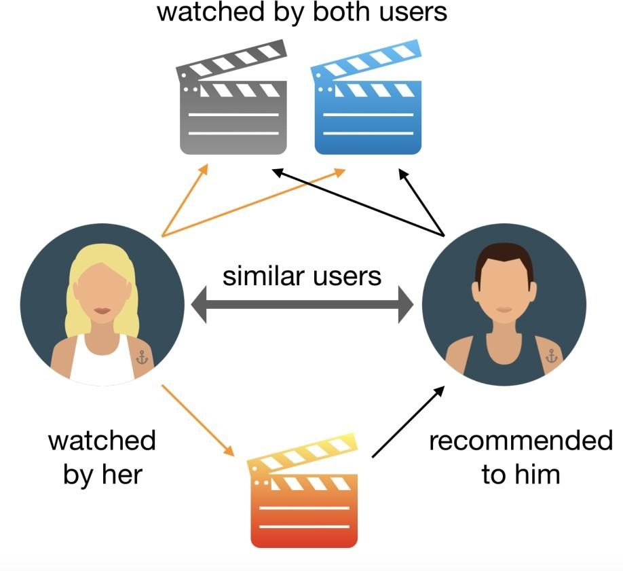

### FIG 3 USER BASED FILTERING

#### 3.3.4 KNN ALGORITHM

The ***K*-nearest neighbors algorithm** (***K*-NN**) is a non-parametric classification method first developed by Evelyn Fix and Joseph Hodges in 1951, and later expanded by Thomas Cover.It is used for Classification and regression. In both cases, the input consists of the *k* closest training examples in data set. The output depends on whether *k*-NN is used for classification or regression:

* In *k-NN classification*, the output is a class membership. An object is classified by a plurality vote of its neighbors, with the object being assigned to the class most common among its *k* nearest neighbors (*k* is a positive integer, typically small). If *k* = 1, then the object is simply assigned to the class of that single nearest neighbor.

* In *k-NN regression*, the output is the property value for the object. This value is the average of the values of *k* nearest neighbors.

*K-NN* is a type of classification where the function is only approximated locally and all computation is deferred until function evaluation. Since this algorithm relies on distance for classification, if the features represent different physical units or come in vastly different scales then normalizing the training data can improve its accuracy dramatically.

Both for classification and regression, a useful technique can be to assign weights to the contributions of the neighbors, so that the nearer neighbors contribute more to the average than the more distant ones. For example, a common weighting scheme consists in giving each neighbor a weight of 1/*d*, where *d* is the distance to the neighbor.

The neighbors are taken from a set of objects for which the class (for *k*-NN classification) or the object property value (for *k*-NN regression) is known. This can be thought of as the training set for the algorithm, though no explicit training step is required.

1. Find the K-nearest neighbors (KNN) to the user ***a,*** using a similarity function ***w*** to measure the distance between each pair of users:



1. Predict the rating that user ***a*** will give to all items the ***k*** neighbors have consumed but ***a*** has not. We look for the item ***j*** with the best predicted rating.

**CHAPTER 4**

**MODULE DESCRIPTION 4.1 SYSTEM STUDY**

A recommendation engine is a system that suggests products, services, information to users based on analysis of data. Notwithstanding, the recommendation can derive from a variety of factors such as the history of the user and the behaviour of similar users.

Recommendation systems are quickly becoming the primary way for users to expose to the whole digital world through the lens of their experiences, behaviours, preferences and interests. And in a world of information density and product overload, a recommendation engine provides an efficient way for companies to provide consumers with personalised information and solutions.

#### 4.1.1 BENEFITS

A recommendation engine can significantly boost revenues, Click-Through Rates (CTRs), conversions, and other essential metrics. It can have positive effects on the user experience, thus translating to higher customer satisfaction and retention.

Let’s take Netflix as an example. Instead of having to browse through thousands of box sets and movie titles, Netflix presents you with a much narrower selection of items that you are likely to enjoy. This capability saves you time and delivers a better user experience. With this function, Netflix achieved lower cancellation rates, saving the company around a billion dollars a year.

Although recommendation systems have been used for almost 20 years by companies like Amazon, it has been proliferated to other industries such as finance and travel during the last few years.

#### 4.1.2 DIFFERENT TYPES

The most common types of recommendation systems are CONTENT-BASED and COLLABORATIVE

FILTERING recommendation systems. In collaborative filtering, the behavior of a group of users is used to make recommendations to other users. The recommendation is based on the preference of other users. A simple example would be recommending a movie to a user based on the fact that their friend liked the movie. There are two types of collaborative models MEMORY-BASED methods and MODEL-BASED methods. The advantage of memory-based techniques is that they are simple to implement and the resulting recommendations are often easy to explain. They are divided into two:

* **User-based collaborative filtering**: In this model, products are recommended to a user based on the fact that the products have been liked by users similar to the user. For example, if Derrick and Dennis like the same movies and a new movie come out that Derick like, then we can recommend that movie to Dennis because Derrick and Dennis seem to like the same movies.
* **Item-based collaborative filtering**: These systems identify similar items based on users’ previous ratings. For example, if users A, B, and C gave a 5-star rating to books X and Y then when a user D buys book Y they also get a recommendation to purchase book X because the system identifies book X and Y as similar based on the ratings of users A, B, and C.

Model-based methods are based on Matrix Factorization and are better at dealing with sparsity. They are developed using data mining, machine learning algorithms to predict users’ rating of unrated items. In this approach techniques such as dimensionality reduction are used to improve accuracy. Examples of such model-based methods include Decision trees, Rule-based Model, Bayesian Model, and latent factor models.

* **Content-based systems** use metadata such as genre, producer, actor, musician to recommend items say movies or music. Such a recommendation would be for instance recommending Infinity War that featured Vin Diesel because someone watched and liked The Fate of the Furious. Similarly, you can get music recommendations from certain artists because you liked their music. Content-based systems are based on the idea that if you liked a certain item you are most likely to like something that is similar to it.

#### 4.1.3 CHALLENGES A RECOMMENDATION SYSTEM FACE

1. Sparsity of data. Data sets filled with rows and rows of values that contain blanks or zero values. So finding ways to use denser parts of the data set and those with information is critical.

1. Latent association. Labelling is imperfect. Same products with different labelling can be ignored or incorrectly consumed, meaning that the information does not get incorporated correctly.

1. Scalability. The traditional approach has become overwhelmed by the multiplicity of products and clients. This becomes a challenge as data sets widen and can lead to performance reduction.

### 4.2 DATA PRE-PROCESSING

For k-NN-based model, the underlying dataset ml-100k from the Surprise Python sci-unit was used. Shock may be a tight call in any case, to search out out regarding recommendation frameworks. It’s acceptable for building and examining recommendation frameworks that manage unequivocal rating data.

### 4.3 MODEL BUILDING

Information is an element into a seventy fifth train take a look at and twenty fifth holdout take a look at. Grid Search CV completed over five - overlap, is employed to find the most effective arrangement of closeness live setup (sim_options) for the forecast calculation. It utilizes the truth measurements because the premise to get completely different mixes of sim options, over a cross-approval system.

**4.4 DATA SET USED:**

we are using the Movie Lens Data Set. This dataset was put together by the Group lens research group at the University of Minnesota. It contains 1, 10, and 20 million ratings. Movie lens also has a website where you can sign up, contribute reviews and get movie recommendations.

**4.5 RECOMMENDATION VISUALIZATION:**

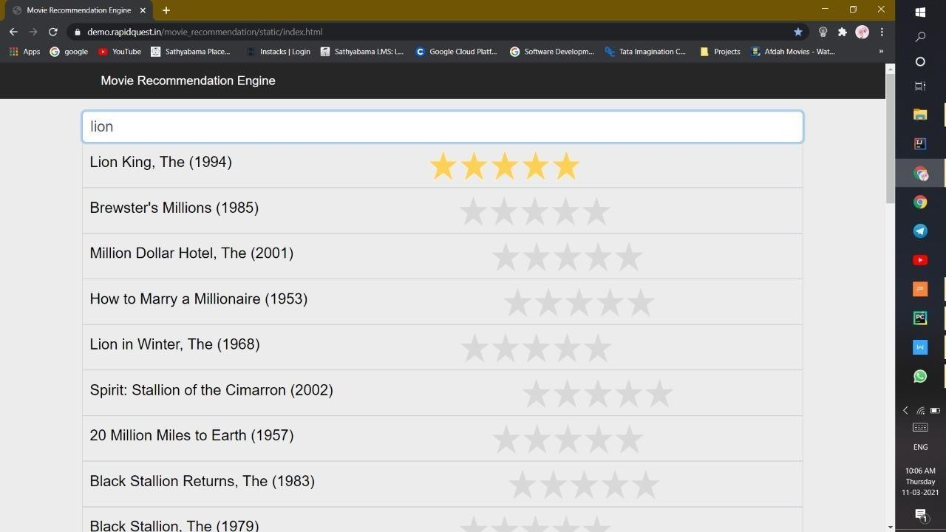

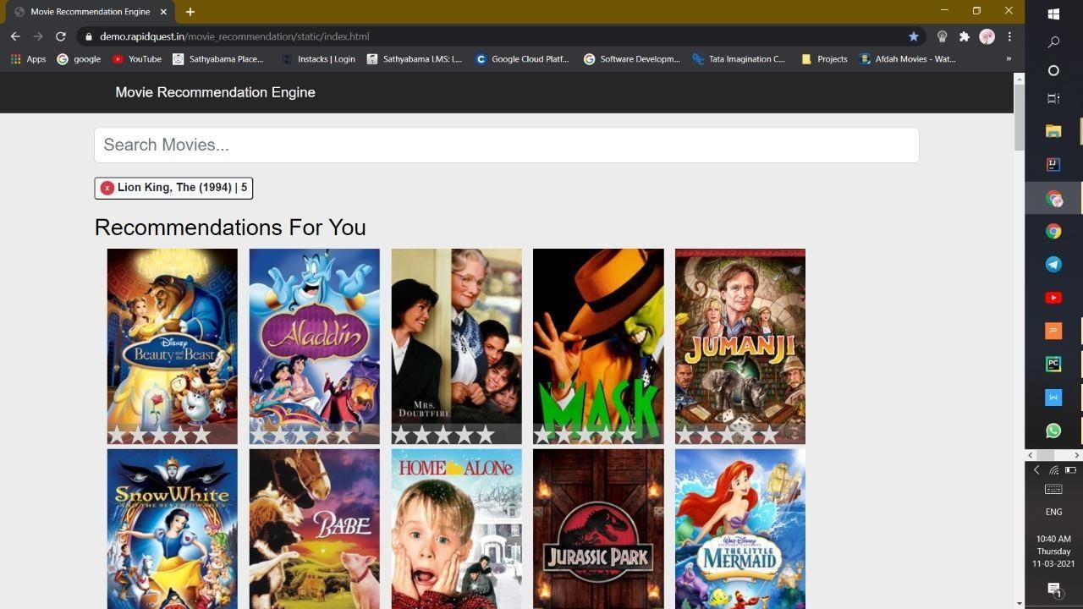

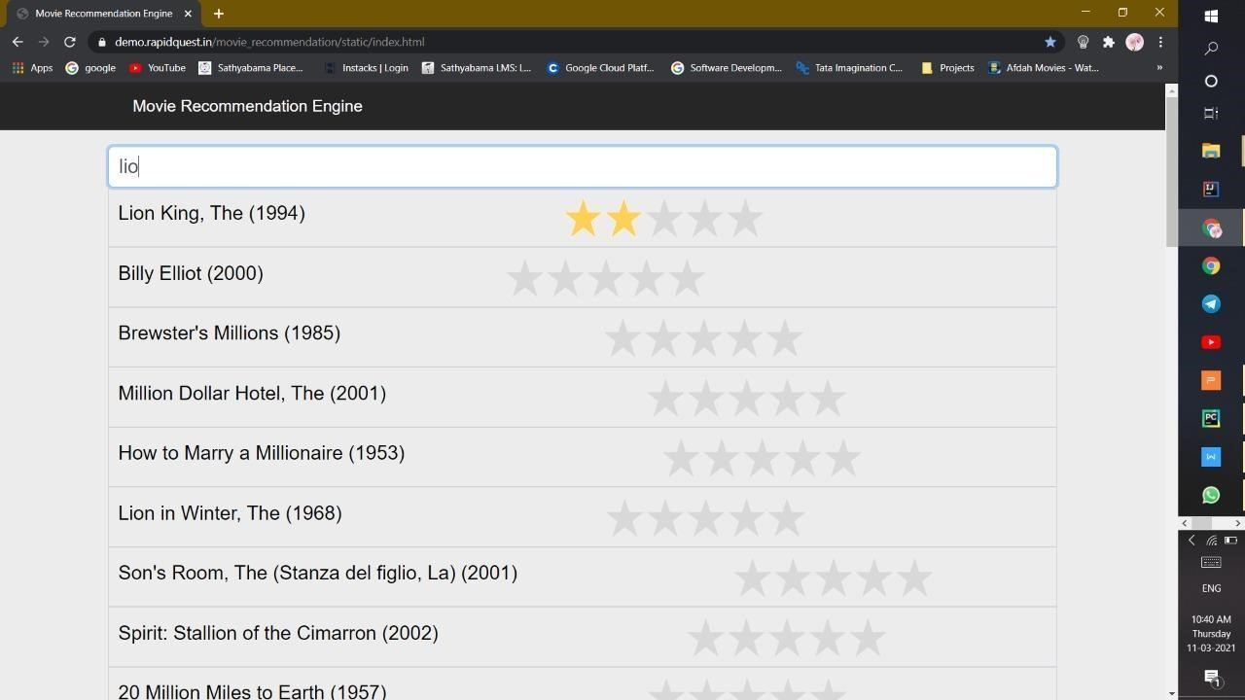

**CHAPTER 5**

**RESULT CONCLUSION AND DISCUSSION**

### 5.1 CONCLUSION

In the last few decades, recommendation systems have been used, among the many available solutions, in order to mitigate information and cognitive overload problem by suggesting related and relevant items to the users. In this regards, numerous advances have been made to get a high-quality and fine-tuned recommendation system. Nevertheless, designers face several prominent issues and challenges. Although, researchers have been working to cope with these issues and have devised solutions that somehow and up to some extent try to resolve these issues, however we need much to do in order to get to the desired goal. In this research article, we focused on these prominent issues and challenges, discussed what has been done to mitigate these issues, and what needs to be done in the form of different research opportunities and guidelines that can be followed in coping with at least problems like latency, sparsity, context-awareness, grey sheep and cold-start problem.

### 5.2 RESULT

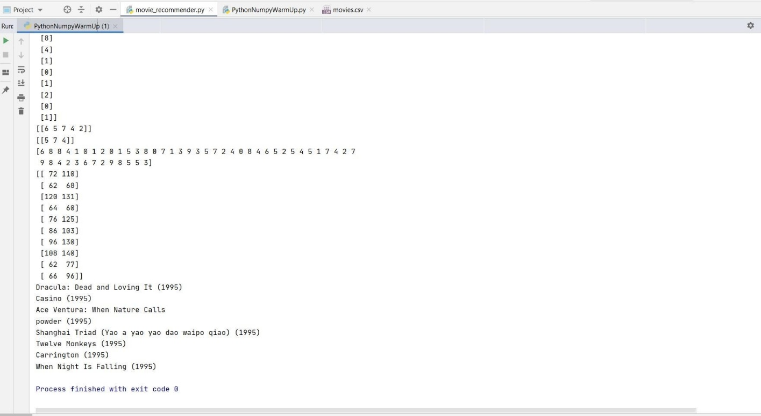

FIG 3 OUTPUT

**APPENDIX:**

**SOURCE CODE:**

from numpy import *

import pandas as pd

num_movies = 10

num_users = 5

ratings = random.randint(11, size=(num_movies, num_users))

movies_df = pd.read_csv(**r"J:\movie recommendation\Movies_Recommendation_system- main\Movies_Recommendation_system-main\movies.csv"**)

*# storing ratings info*

ratings_df = pd.read_csv(**r"J:\movie recommendation\Movies_Recommendation_system- main\Movies_Recommendation_system-main\movies.csv"**) movies_df.head()

movies_df[**'year'**] = movies_df.title.str.extract(**'(\(\d\d\d\d\))'**,expand=False) movies_df[**'year'**] = movies_df.year.str.extract(**'(\d\d\d\d)'**,expand=False)

movies_df[**'title'**] = movies_df.title.str.replace(**'(\(\d\d\d\d\))'**, **''**) movies_df[**'title'**] = movies_df[**'title'**].apply(lambda x: x.strip()) movies_df.head() userInput = [

{**'title'**: **'Breakfast Club, The'**, **'rating'**: 5},

{**'title'**: **'Toy Story'**, **'rating'**: 2.5},

{**'title'**: **'Jumanji'**, **'rating'**: 1},

{**'title'**: **"Pulp Fiction"**, **'rating'**: 5},

{**'title'**: **'Akira'**, **'rating'**: 4.5}

]

inputMovies = pd.DataFrame(userInput)

print(ratings)

did_rate = (ratings != 0) * 1 *#print(did_rate)*

*#print(ratings != 0)*

*#print((ratings != 0)*1)*

ratings.shape

did_rate.shape

nikhil_ratings = zeros((num_movies, 1))

*#print(nikhil_ratings)*

*#print(nikhil_ratings[5])*

*# In[29]:*

nikhil_ratings[0] = 8 nikhil_ratings[4] = 7 nikhil_ratings[7] = 3

*#print(nikhil_ratings)*

ratings = append(nikhil_ratings, ratings, axis=1)

did_rate = append(((nikhil_ratings != 0) * 1), did_rate, axis=1)

*#print(ratings)*

ratings.shape

did_rate *#print(did_rate)*

did_rate.shape

a = [10, 20, 30]

aSum = sum(a)

*#print(aSum)*

aMean = aSum / 3

*#print(aMean)*

aMean = mean(a)

*#print(aMean)*

a = [10 - aMean, 20 - aMean, 30 - aMean]

*#print(a)*

print(ratings)

def normalize_ratings(ratings, did_rate):

num_movies = ratings.shape[0]

ratings_mean = zeros(shape=(num_movies, 1)) ratings_norm = zeros(shape=ratings.shape)

for i in range(num_movies): *# Get all the indexes where there is a 1* idx = where(did_rate[i] == 1)[0]

*# Calculate mean rating of ith movie only from user's that gave a rating* ratings_mean[i] = mean(ratings[i, idx])

ratings_norm[i, idx] = ratings[i, idx] - ratings_mean[i] return ratings_norm, ratings_mean

ratings, ratings_mean = normalize_ratings(ratings, did_rate)

num_users = ratings.shape[1] num_features = 3

1. = array([[1, 2], [1, 5], [1, 9]])

Theta = array([[0.23], [0.34]])

*#print(X)*

*#print(Theta)*

1. = X.dot(Theta)

*#print(Y)*

movie_features = random.randn(num_movies, num_features) user_prefs = random.randn(num_users, num_features)

initial_X_and_theta = r_[movie_features.T.flatten(), user_prefs.T.flatten()]

print(movie_features)

*#print(user_prefs)*

*#print(initial_X_and_theta)*

initial_X_and_theta.shape

movie_features.T.flatten().shape

user_prefs.T.flatten().shape

initial_X_and_theta

def unroll_params(X_and_theta, num_users, num_movies, num_features):

*# Retrieve the X and theta matrixes from X_and_theta, based on their dimensions (num_features, num_movies, num_movies)*

*# Get the first 30 (10 * 3) rows in the 48 X 1 column vector* first_30 = X_and_theta[:num_movies * num_features]

*# Reshape this column vector into a 10 X 3 matrix*

X = first_30.reshape((num_features, num_movies)).transpose()

*# Get the rest of the 18 the numbers, after the first 30* last_18 = X_and_theta[num_movies * num_features:] *# Reshape this column vector into a 6 X 3 matrix*

theta = last_18.reshape(num_features, num_users).transpose() return X, theta

def calculate_gradient(X_and_theta, ratings, did_rate, num_users, num_movies, num_features, reg_param):

X, theta = unroll_params(X_and_theta, num_users, num_movies, num_features)

*# we multiply by did_rate because we only want to consider observations for which a rating was given* difference = X.dot(theta.T) * did_rate - ratings X_grad = difference.dot(theta) + reg_param * X theta_grad = difference.T.dot(X) + reg_param * theta

return r_[X_grad.T.flatten(), theta_grad.T.flatten()]

def calculate_cost(X_and_theta, ratings, did_rate, num_users, num_movies, num_features, reg_param):

X, theta = unroll_params(X_and_theta, num_users, num_movies, num_features)

cost = sum((X.dot(theta.T) * did_rate - ratings) ** 2) / 2

regularization = (reg_param / 2) * (sum(theta**2) + sum(X**2)) return cost + regularization

*#* from scipy import optimize

reg_param = 30

minimized_cost_and_optimal_params = optimize.fmin_cg(calculate_cost,

fprime=calculate_gradient, x0=initial_X_and_theta, args=(ratings, did_rate, num_users,

num_movies, num_features, reg_param), maxiter=100, disp=True, full_output=True)

cost, optimal_movie_features_and_user_prefs = minimized_cost_and_optimal_params[1], minimized_cost_and_optimal_params[0]

movie_features, user_prefs = unroll_params(optimal_movie_features_and_user_prefs, num_users, num_movies, num_features)

print(movie_features) print(user_prefs)

all_predictions = movie_features.dot(user_prefs.T)

predictions_for_nikhil = all_predictions[:, 0:1] + ratings_mean

print(predictions_for_nikhil) print(nikhil_ratings)

#### VI RESULT AND DISCUSSION



**FIG 2 COLLABORATIVE FILTERING**

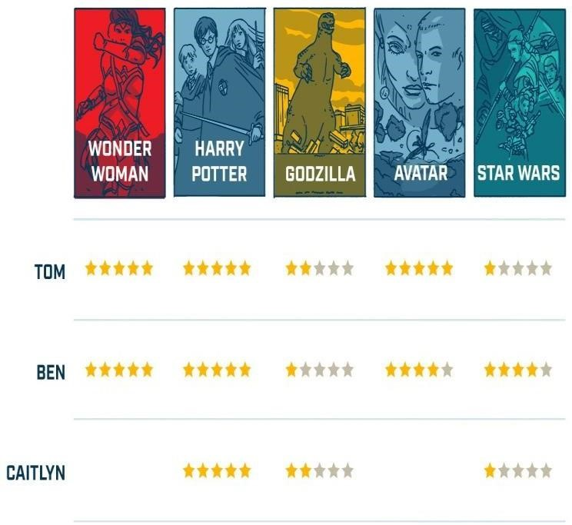

**FIG 3 SAMPLE PICTURE OF RATING**



### FIG 4 DATA SET

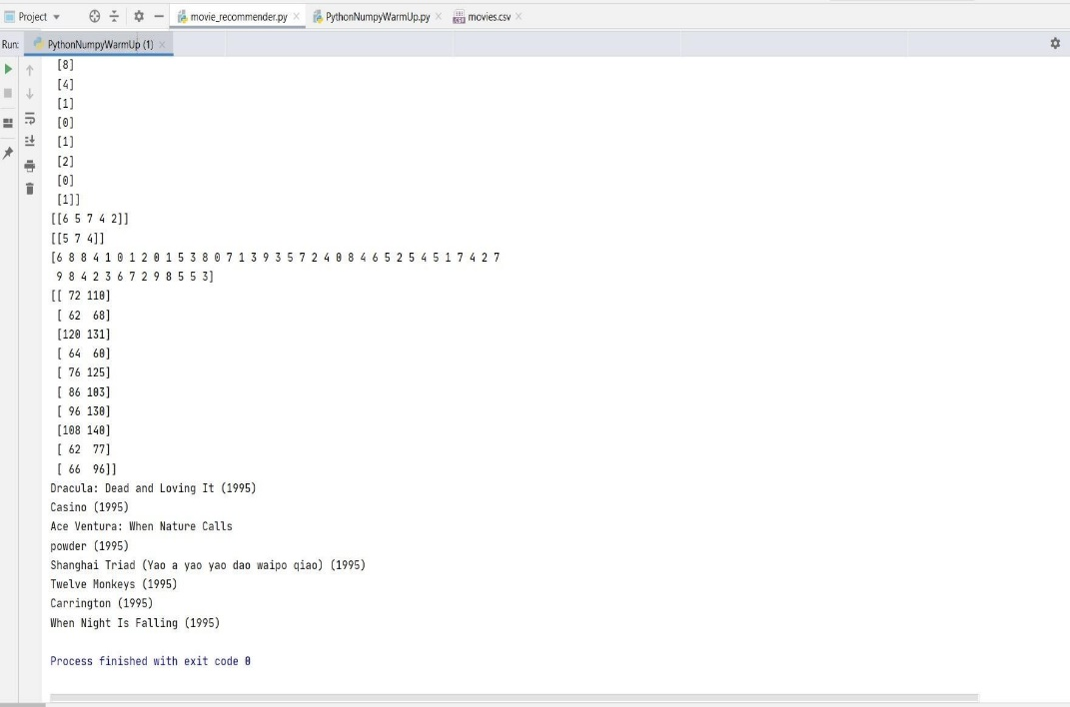

### FIG 5 OUTPUT

#### VII CONCLUSION

This paper incorporates a summation survey of writing considers known with the film proposal framework smitten by cooperative separating. Numerous methodologies, Userbased separating, Item-based separation, subbing least sq. strategies,KNN strategy, and for execution estimation of those framework Root mean sq. technique (RMSE)[3], Mean sq. method(MSE), giant scale and miniature received the centre of f- measure were used in investigations. Every investigation has its qualities and constraints. In future work, a movie suggestion will improve by utilizing the Pytorch library whereby a model would be ready to get the dormant (Hidden) factors. Under the state of monumental information, the requirements of film proposal framework from film beginner square measure increasing. This text plans and executes a complete film suggestion framework model smitten by the KNN calculation, community separation calculation and proposal framework technology[18]. We tend to provide a purpose by purpose set up and advancement interaction, and take a look at the soundness and high productivity of examination framework through adept take a look at. This paper has reference importance for the development of customized suggestion Innovation.

##### REFERENCES

1. Bobadilla J, Ortega F, Hernando A, Gutiérrez A (2013) Recommender systems survey. Knowl Based

Syst 46:109–132.<https://doi.org/10.1016/j.knosys.2013.03.012>

1. Cui, Bei-Bei. (2017). Design and Implementation of Movie Recommendation System Based on Knn Collaborative Filtering Algorithm. ITM Web of Conferences. 12. 04008. 10.1051/itmconf/20171204008.
2. Fadhel Aljunid, Mohammed & D H, Manjaiah. (2018). Movie Recommender System Based on

Collaborative Filtering Using Apache Spark. [https://doi.org/10.1007/978- 981-13-1274-8_22](https://doi.org/10.1007/978-%20981-13-1274-8_22)

1. Miryala, Goutham & Gomes, Rahul & Dayananda, Karanam. (2017). COMPARATIVE ANALYSIS OF MOVIE RECOMMENDATION SYSTEM USING COLLABORATIVE FILTERING IN SPARK ENGINE.

Journal of Global Research in Computer Science. 8. 10-14.

1. Banerjee, Anurag & Basu, Tanmay. (2018). Yet Another Weighting Scheme for Collaborative Filtering Towards Effective Movie Recommendation.
2. Zhao, Zhi-Dan & Shang, Ming Sheng. (2010). UserBased Collaborative-Filtering Recommendation

Algorithms on Hadoop. 3rd International Conference on Knowledge Discovery and Data Mining, WKDD 2010. 478- 481.<https://doi.org/10.1109/WKDD.2010.54>

1. Kharita, M. K., Kumar, A., & Singh, P. (2018). ItemBased Collaborative Filtering in Movie

Recommendation in Real-time. 2018 First International Conference on Secure Cyber Computing and

Communication (ICSCCC). DOI:10.1109/icsccc.2018.8703362

1. A. V. Dev and A. Mohan, "Recommendation system for big data applications based on the set similarity of user preferences," 2016 International Conference on Next Generation Intelligent Systems (ICNGIS), Kottayam, 2016, pp. 1-6. DOI: 10.1109/ICNGIS.2016.7854058

1. Subramaniyaswamy, V., Logesh, R., Chandrashekhar, M., Challa, A. and Vijayakumar, V. (2017) ‘A personalized movie recommendation system based on collaborative filtering,’ Int. J. HighPerformance Computing and Networking, Vol. 10, Nos. 1/2, pp.54–63.
2. Thakkar, Priyank & Varma (Thakkar), Krunal & Ukani, Vijay & Mankad, Sapan & Tanwar, Sudeep. (2019). Combining UserBased and Item-Based Collaborative Filtering Using Machine Learning: Proceedings of ICTIS 2018, Volume 2. 10.1007/978-981-13-1747- 7_17
3. Wu, Ching-Seh & Garg, Deepti & Bhandary, Unnathi. (2018). Movie Recommendation System Using Collaborative Filtering. 11-15. 10.1109/ICSESS.2018.8663822.
4. Verma, J. P., Patel, B., & Patel, A. (2015). Big data analysis: Recommendation system with Hadoop framework. In 2015 IEEE International Conference on Computational Intelligence & Communication Technology (CICT). IEEE.
5. Zeng, X., et al. (2016). Parallelization of the latent group model for group recommendation algorithm. In IEEE International Conference on Data Science in Cyberspace (DSC). IEEE.
6. Katarya, R., & Verma, O. P. (2017). An effective collaborative movie recommender system with a cuckoo search. Egyptian Informatics Journal, 18(2), 105–112. DOI:10.1016/j.eij.2016.10.002 [15] Phorasim, P., & Yu, L. (2017). Movies recommendation system

1. Using collaborative filtering and k-means. DOI:10.19101/IJACR.2017.729004 M Shamshiri, GO Sing, YJ Kumar, International Journal of Computer Information Systems and Industrial Management Applications(2019).